

**Copyright © October 2019**

**IoT Using LoRaWAN**

**CSE3PR Industry Project**

**Team F – System Maintenance Document**

James Curnow

Joel Morran

Michael Owczarek

Remi Petit

Luis Shigetomi

# Table of Contents

Title 1

Table of Contents 2

Table of Figures 4

1.0 – Introduction 5

1.1 – System Overview 5

1.2 – Audience Description 7

1.3 – Applicability Statement 7

1.4 – Statement of Purpose 7

1.5 – Document Usage Description 8

1.6 – Conventions 8

2.0 – System Design Scope 9

2.1 – Major System Functions 9

2.2 – Major Design Constraints and Other Requirements 9

3.0 – Reference Documents 10

3.1 – Existing Software Documentation 10

3.2 – System Documentation 10

3.3 – Vendor Documentation 10

4.0 – User Stories 11

4.1 – User Story Dictionary 11

4.2 – Iterative User Story Documents 11

4.2.1 – User Story Definition 11

4.2.2 – Flow of Interaction Diagram 12

4.2.3 – Wireframes 14

5.0 – Object-Oriented Design 17

5.1 – High Level System Architecture 17

5.2 – High Level Package Diagram 18

5.3 – Use Case Analysis 19

5.3.1 – Use Case Diagram 19

5.3.2 – Use Case Analysis 20

5.4 – Sequence Diagram 21

5.5 – Methods Reference 22

6.0 – Software Release Report 23

6.1 – Usability Test Report 23

6.1.1 – Questionnaire Template 24

6.1.2 – Questionnaire Example 1 25

6.1.3 – Questionnaire Example 2 26

6.2 – User Story Testing 27

7.0 – Appendix 28

7.1 – Glossary 28

7.2 – References / Bibliography 29

7.3 – Statement of Authorship 30

# Table of Figures

Figure 1 - Block Diagram 5

Figure 2 - FIN Diagram 1 12

Figure 3 - FIN Diagram 2 13

Figure 4 - Dashboard Wireframe 14

Figure 5 - User Story 1 14

Figure 6 - User Story 2 15

Figure 7 - User Story 3 15

Figure 8 - User Story 4 (Step 1) 16

Figure 9 - User Story 4 (Step 2) 16

Figure 10 - System Architecture Diagram 17

Figure 11- UML Diagram 18

Figure 12 - Use Case Diagram 19

Figure 13 - Sequence Diagram 21

# 1.0 – Introduction

## 1.1 – System Overview

The IoT Using LoRaWAN system aims to deliver the following outcomes:

* A group of sensors connected through LoRaWAN to a gateway
* A connection through the gateway directly to the IoT platform for sending and receiving the collected data
* An IoT platform set up for managing the data to and from the sensors
* A visualisation environment to illustrate the sensors activities
* A data processing algorithm to extract features and detect certain patterns in the logged data

The following block diagram portrays the system:

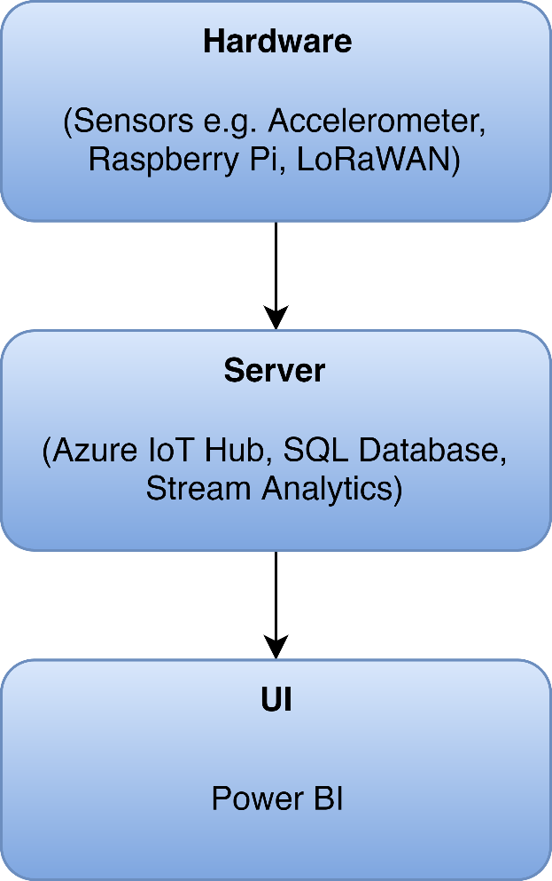

Figure 1 - Block Diagram

**Hardware:** Consists of the physical components of the software responsible for sensor data transmission to the server side of the project. This consists of a Raspberry Pi, a Seeeduino with GPS and a Grove Accelerometer.

**Server:** Microsoft’s Azure platform will be used for anything server side. This includes an IoT Hub used to manage the IoT devices as well as the system’s database.

**User Interface:** The UI components are provided by Microsoft’s Power BI.

## 1.2 – Audience Description

There are two types of users for the system:

**Primary:** The IoT using LoRaWAN project is intended for use by staff at the LaTrobe University Centre for Technology Infusion.

**Secondary:** The system is also being developed with the hope that it can be marketed and used by various people with specific needs. For example, farmers could use the system in order to track their cattle’s behavior and movement patterns

Specifically this system will be used by users to understand and perform data analysis on data that is created by sensors on subjects, through a simple UI which displays the data effectively.

For both user types, basic computer skills are required. Knowledge of how Power BI works is beneficial but not required.

## 1.3 – Applicability Statement

The system hardware is run on a Raspberry Pi and Arduino sensors, and is managed through Microsoft’s Azure.

The Raspberry Pi runs Raspbian, a Linux distribution for embedded computers and was supported with the following technologies: Keras 2.3.0, TensorFlow 2.0, Python: 3+. And the Arduino sensors runs on it’s own IDE, Arduino 1.8.10.

The system is accessed by the user using any web browser that supports Microsoft’s Power BI which takes uploaded data from Microsoft SQL Server. The user can also access the Azure IoT Hub online should they ever want to manage their devices.

## 1.4 – Statement of Purpose

The purpose of the IoT using LoRaWAN project is to:

* Create a visualization environment for sensor activity
* Provide an environment capable of handling additional sensors
* Provide separate restricted views of data for users based on their role in the system
* Display sensor specific data in an understandable format

This project’s aim is to implement a LoRaWAN sensor network with a few sensors to generate data and present/visualise it for a user.

## 1.5 – Document Usage Description

**1 – Introduction:**

Consists of a short description outlining an overview of the system, it also discusses the audience and provides purpose of the usage of the document. The conventions used on the document and changelog are also included.

**2 – Software Design Scope:**

Outlines a couple of the software components that are used in a predominately hardware-based project. Any design constraints and further requirements are also included.

**3 – Referencing Documents:**

Provides a detailed description of any documentation used in relation to the system.

**4 – User Stories:**

Consists of user stories that are taken into the consideration of the system. A user story dictionary as well as testing and wireframes are also included.

**5 – Object-Oriented Design:**

Any diagrams and descriptions relating to the architecture of the system are included in this part of the document.

**6 – Software Release Report:**

System usability and any testing performed are included in this section of the documentation.

**7 – Setup/Installation Guide:**

Describes how to setup up the system and install the necessary hardware.

**8 – Special Notes:**

Additional information is included in this section of the document such as a glossary or any further comments that are not included elsewhere.

## 1.6 – Conventions

The following conventions are used throughout the document:

* A consistent styling theme is kept throughout the document to maintain readability.
* Numbered headings are included to allow easy navigation.
* Each image in this document is numbered and titled

# 2.0 – System Design Scope

## 2.1 – Major System Functions

The main function of the system is to record and display various behavioral and movement patterns of a subject (person or animal). This is achieved by using an accelerometer and GPS attached to the subject which is then sent to Power BI via a LoRaWAN gateway and then displayed to the user using various analytical tools.

**User:**

* View captured data in the form of graphs and charts
* Export the data in various formats

**System:**

* Capture data from an Arduino GPS and accelerometer
* Send data from Arduino to LoRaWAN gateway
* Decode the data and send it to an Azure database
* Performs various analytics on the data in the database

## 2.2 – Major Design Constraints and Other Requirements

**Constraints:**

* The cost of running the Azure deployment must be considered as running a stream analytics job can be very cost intensive.
* The project inherits any constraints from the systems and components (Azure, Power BI, Raspbian, etc.) that it utilises.

**Other Requirements:**

* The LoRaWAN gateway requires a strong, stable network in order to function properly and send each packet to Azure.
* Power BI also requires a persistent internet connection.

# 3.0 – Reference Documents

## 3.1 – Existing Software Documentation

The following documents are supplied in the final submission folder:

* 2019 Industry Project Summary.pdf
* LoRaWan CTI setup.pdf

## 3.2 – System Documentation

The software is not being developed from an embedded existing system.

## 3.3 – Vendor Documentation

**Microsoft Azure:** Microsoft Azure is a cloud computing service created by Microsoft for building, testing, deploying, and managing applications and services through Microsoft-managed data centers.

<https://azure.microsoft.com/en-au/>

<https://docs.microsoft.com/en-us/azure/iot-edge/how-to-install-iot-edge-linux-arm>

<https://azure.microsoft.com/en-au/resources/samples/custom-vision-service-iot-edge-raspberry-pi/>

**Raspberry Pi:** The Raspberry Pi is a series of small single-board computers used to promote teaching of basic computer science in schools and in developing countries.

<https://www.raspberrypi.org/documentation/>

**Arduino:** Arduino is an open-source hardware and software company, project and user community that designs and manufactures single-board microcontrollers and microcontroller kits.

<https://www.arduino.cc/en/Main/Docs>

**Seeeduino:** Seeeduino V4.2 is an Arduino-compatible board, which is based on ATmga328P MCU.

<http://wiki.seeedstudio.com/LoRa_LoRaWan_Gateway_Kit/>

<http://wiki.seeedstudio.com/Seeeduino_LoRAWAN/>

<http://wiki.seeedstudio.com/Grove-IMU_9DOF_v2.0/>

**Power BI:** Power BI is a business analytics service by Microsoft. It aims to provide interactive visualizations and business intelligence capabilities with an interface simple enough for end users to create their own reports and dashboards.

<https://powerbi.microsoft.com/en-us/learning/>

<https://docs.microsoft.com/en-us/power-bi/desktop-getting-started>

**Python:** Python is an interpreted, high-level, general-purpose programming language.

<https://docs.python.org/3/>

# 4.0 – User Stories

## 4.1 – User Story Dictionary

**US-1:** “As a user, I want to view a pie chart of the subject’s behaviour”

**US-2:** “As a user, I want view a map of the subject’s location”

**US-3:** “As a user, I want to see a table to list the raw data”

**US-4:** “As a user, I would like to have the option to filter data”

## 4.2 – Iterative User Story Documents

### 4.2.1 – User Story Definition

**US-1:** “**As a user, I want to view a pie chart of the subject’s behaviour”**

The aim of this user story is for a pie chart to be displayed in the window to show the ratio of different ‘Activity’s that a subject has performed according to recorded data from the database. So that the user may easily interpret the behavioural patterns of a given subject.

**US-2: “As a user, I want view a map of the subject’s location”**

This user story has a representation of a subject’s movement on a map; showing their location at different times as they move using recorded data from the database. Giving the users the ability to visualise the subject’s movements over a large area.

**US-3: “As a user, I want to see a table to list the raw data”**

This user story is to give the user a table with raw data of the recorded data from the database. Showing all attributes; what any subject’s location and is and what they’re so I can see what they’re doing at any time.

**US-4:** **“As a user, I would like to have the option to filter data.”**

The aim of this user story is to provide user with the ability to filter data, by any of the attributes i.e. activity, date/time, device etc. so that they may be able to interpret and analyse the data in specific conditions.

### 4.2.2 – Flow of Interaction Diagram

As US-1, US-2 and US-3 operate the same way because they all commence on start-up, here is one flow of interaction for all 3 user stories.

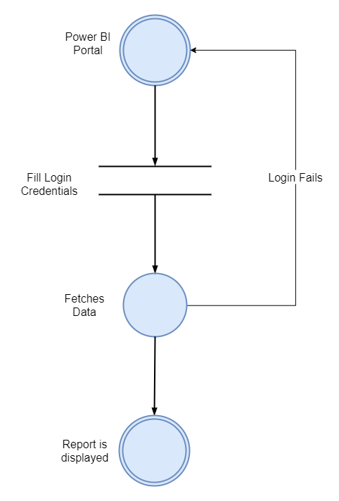

Figure 2 - FIN Diagram 1

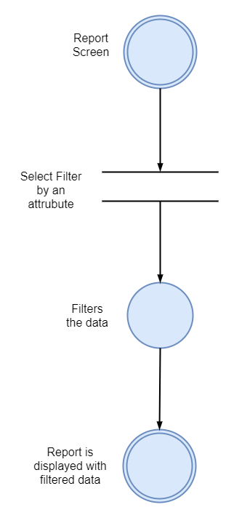

Figure 3 - FIN Diagram 2

### 4.2.3 – Wireframes

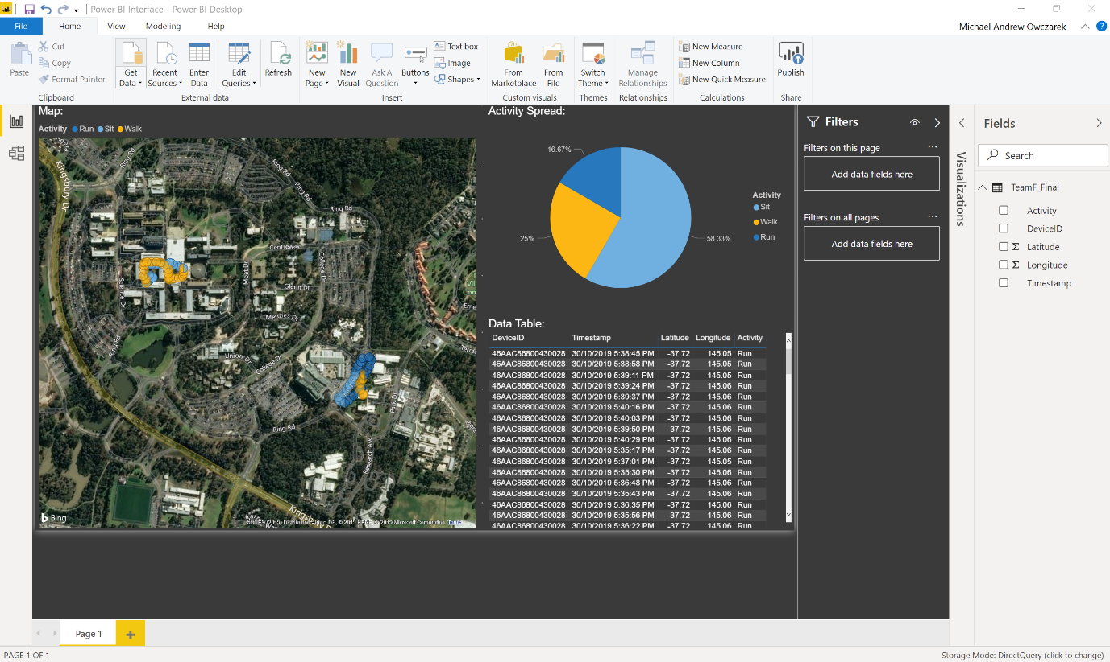

Figure 4 - Dashboard Wireframe

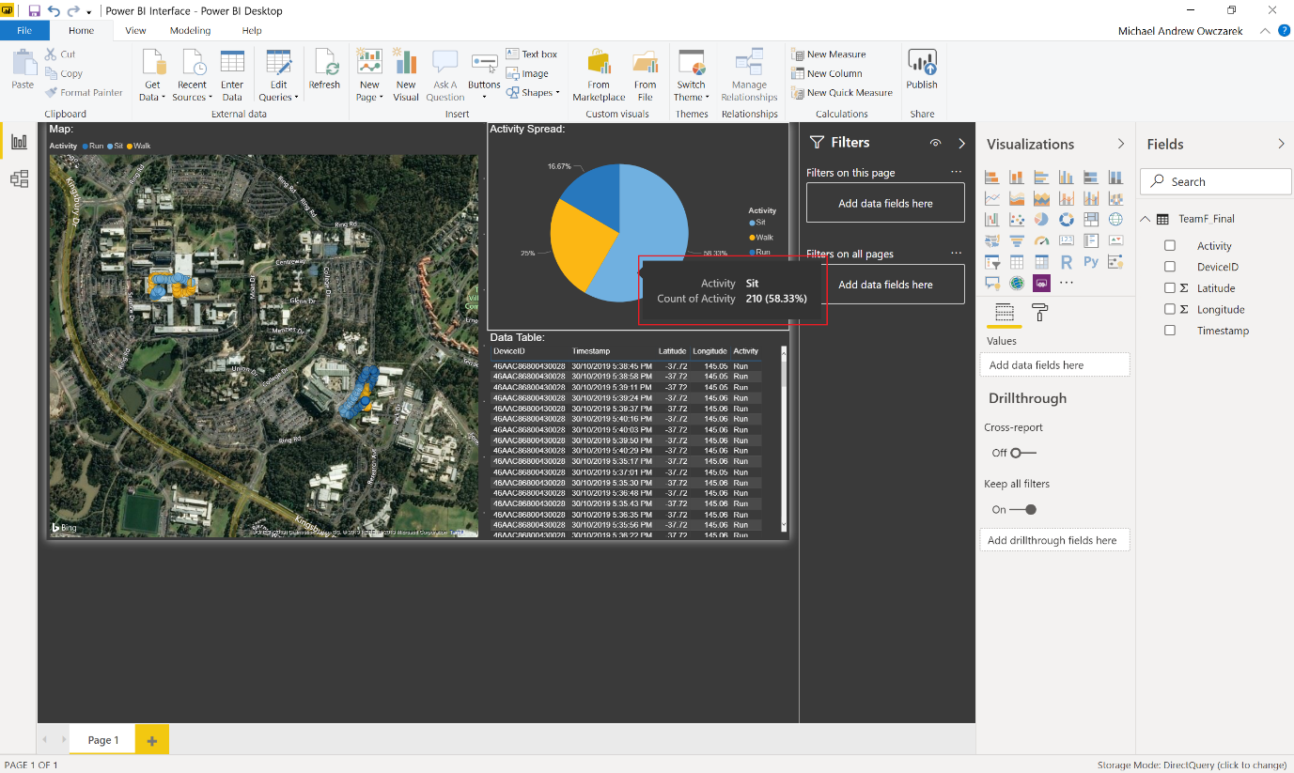

Figure 5 - User Story 1

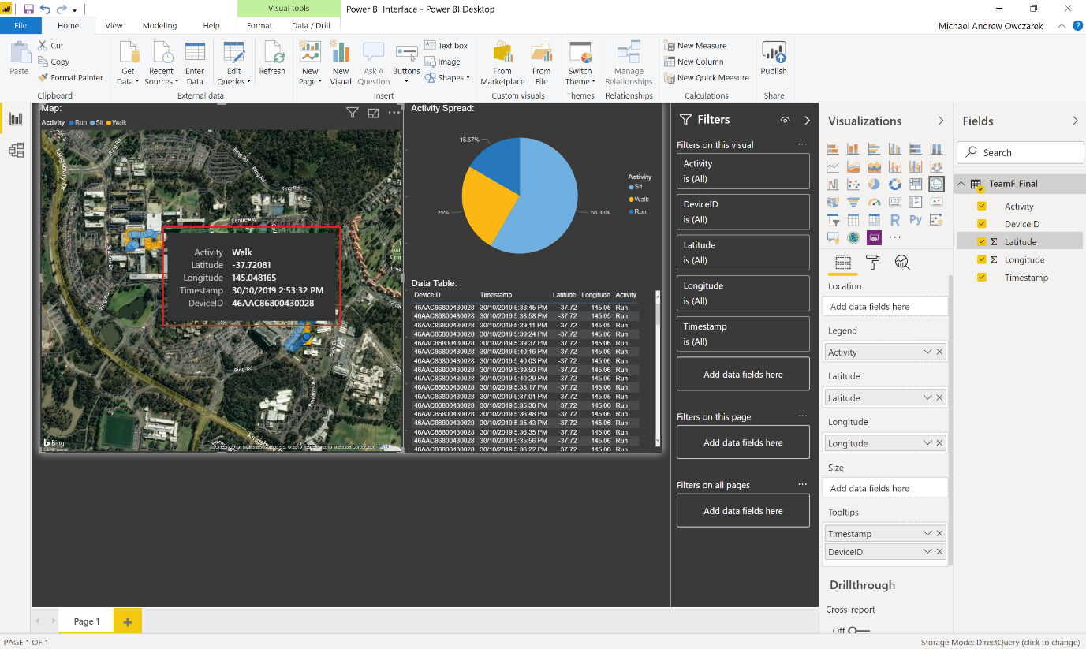

Figure 6 - User Story 2

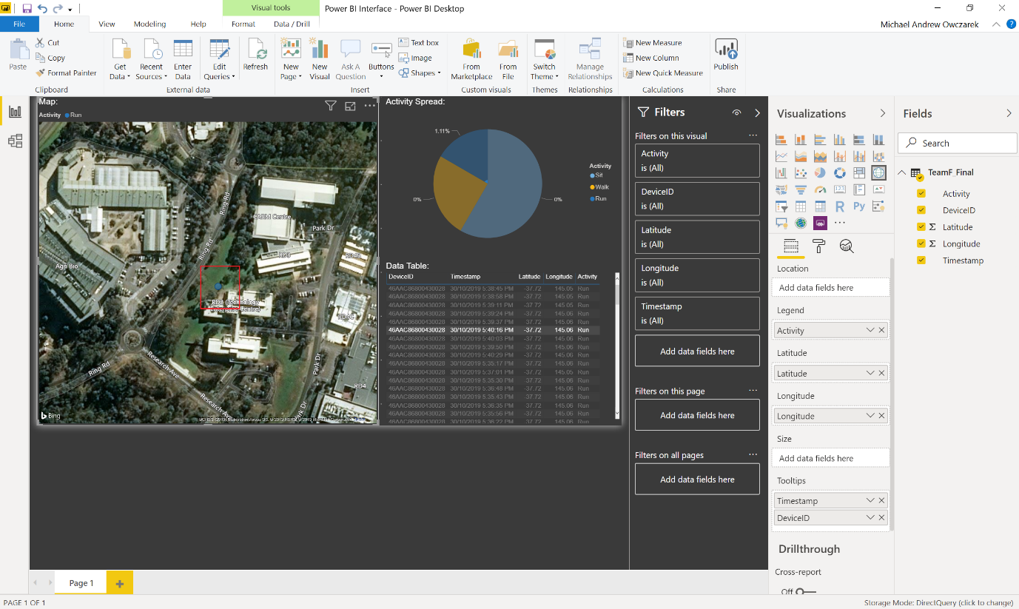

Figure 7 - User Story 3

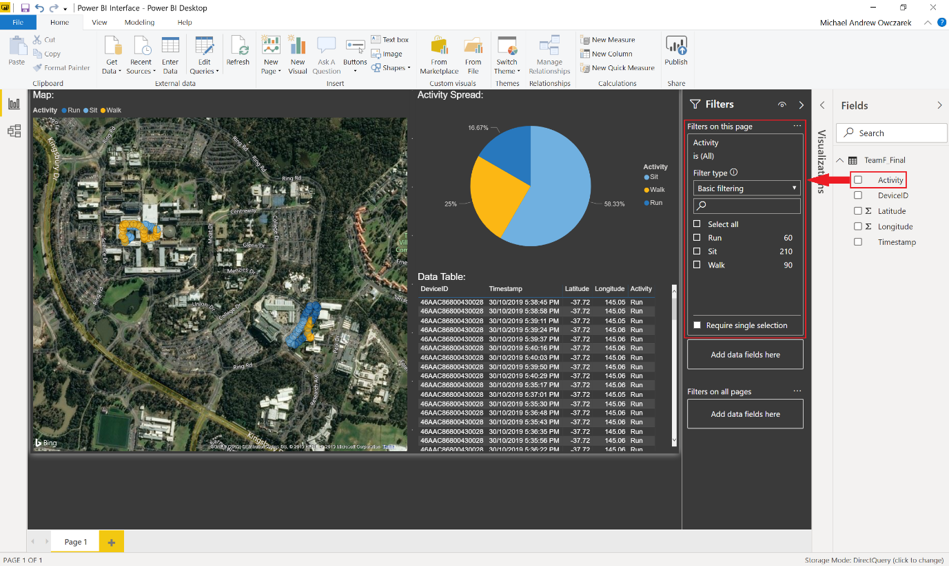

Figure 8 - User Story 4 (Step 1)

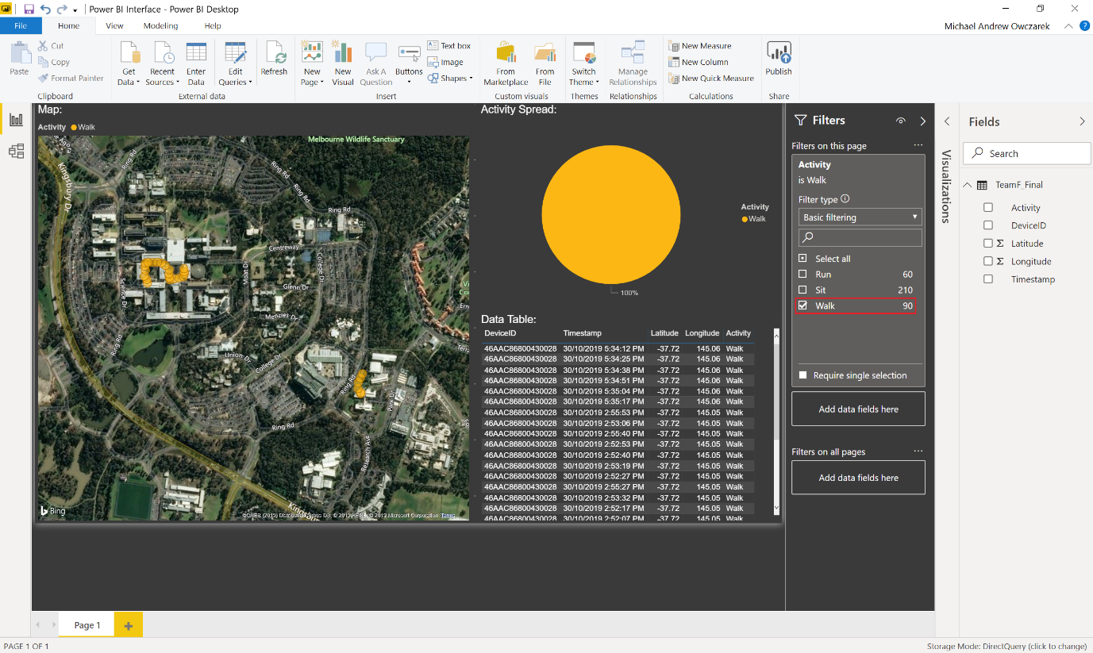

Figure 9 - User Story 4 (Step 2)

# 5.0 – Object-Oriented Design

## 5.1 – High Level System Architecture

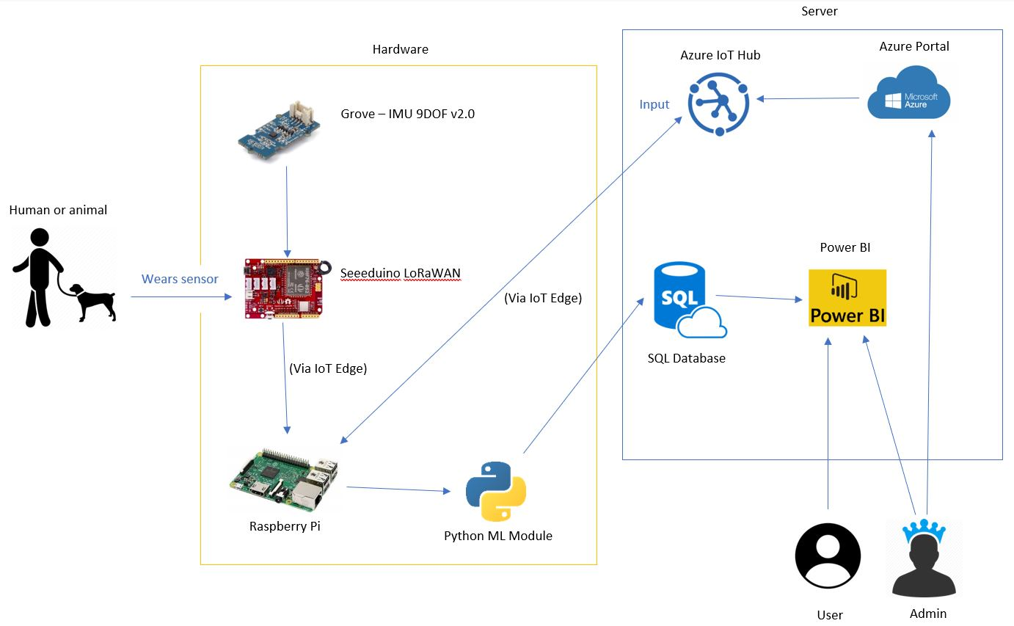

Figure 10 - System Architecture Diagram

## 5.2 – High Level Package Diagram

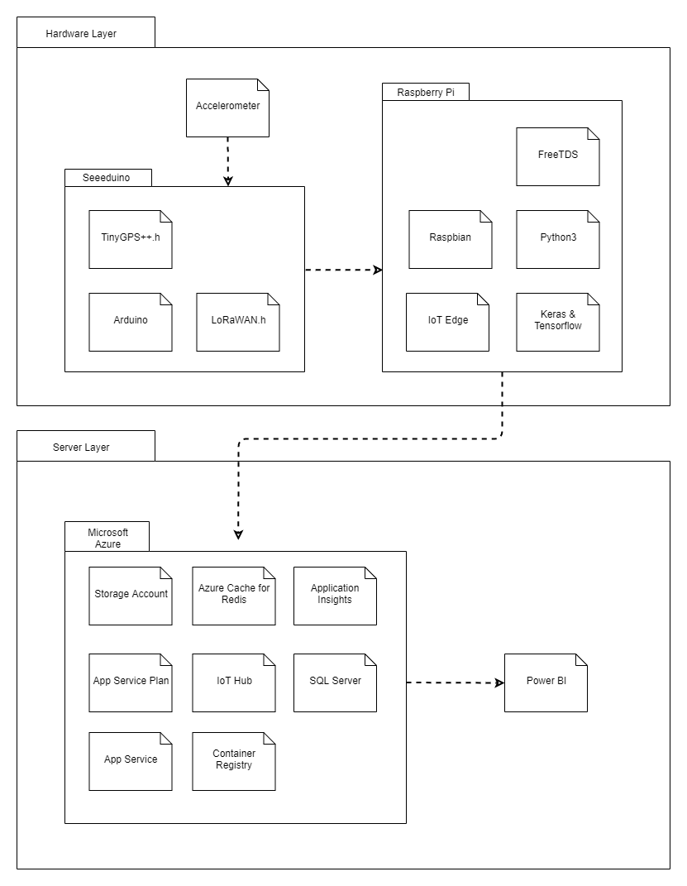

Figure 11- UML Diagram

## 5.3 – Use Case Analysis

### 5.3.1 – Use Case Diagram

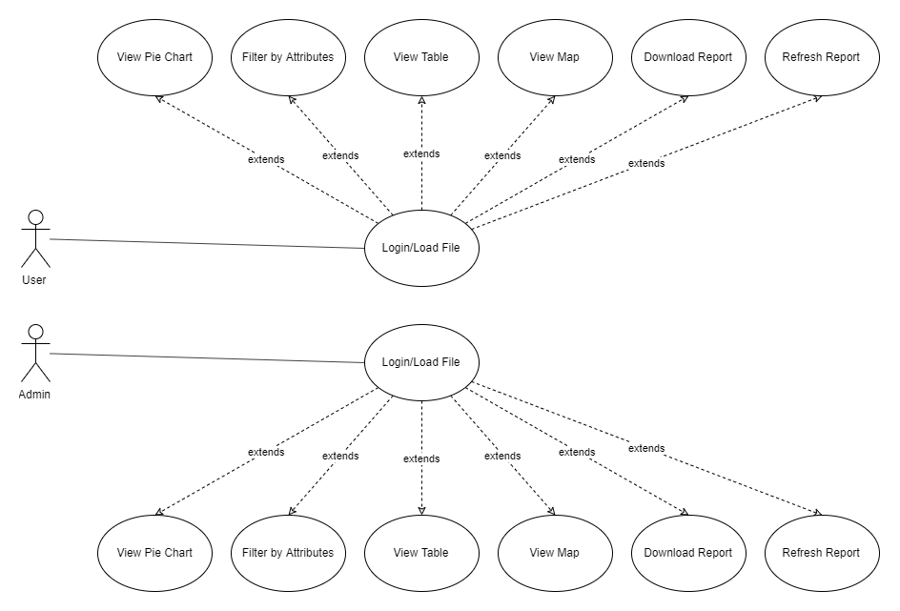

Figure 12 - Use Case Diagram

### 5.3.2 – Use Case Analysis

**USE CASE 1**: User Login

**TRIGGER/GOAL**: A user has entered the website and wants to log in

**ACTOR**: Admin/User

**MAIN FLOW**

1. Actor enters username into the username field and password into the password field
2. User is redirected to the users home page

**EXTENSIONS**

2a - User clicks on the “Back” button on the browser instead 1. Login Screen terminates and User returns to home page.

**USE CASE 2**: Filter by Attributes

**TRIGGER/GOAL**: A user wants to filter data on the dashboard by attributes

**ACTOR**: Admin/User

**MAIN FLOW**

1. User drags attribute from selection of attributes into filter
2. User selects specific range to filter from
3. Report automatically refreshes to reflect filter

**USE CASE 3**: Download Report

**TRIGGER/GOAL**: A user/admin wants to download the report

**ACTOR**: Admin/User

**MAIN FLOW**

1. The user clicks the download report button
2. Alert box appears prompting user to save as to location
3. User selects file location and selects save
4. Report saves to file location

**EXTENSIONS**

3a – The user clicks cancel button during the save as prompt

**USE CASE 4**: Refresh Report

**TRIGGER/GOAL**: A user/admin wants to refresh the data shown in the report

**ACTOR**: Admin/User

**MAIN FLOW**

1. The user clicks the refresh report button
2. Report refreshes

**ALL VIEW USE CASE**: View ‘x’

**TRIGGER/GOAL**: A user/admin wants to see ‘x’

**ACTOR**: Admin/User

**MAIN FLOW**

When user has logged in/loaded file, Pie Chart, Table and Map are already automatically displayed.

**EXTENSIONS**

Non-Applicable

## 5.4 – Sequence Diagram

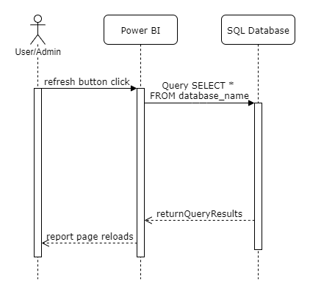

Figure 13 - Sequence Diagram

**NOTE:** This sequence diagram would be almost entirely the same as when the system opens/logs in. Thus only one sequence diagram was deemed necessary.

## 5.5 – Methods Reference

Below listed are all the Objects and their methods developed for this project.

**Function: add_feature(data)**

This function is used to add features to the data. In the current method four features have been added which are Magnitude_vector, Axis1*Axis2, Axis2*Axis3, Axis1*Axis3. It has only one input parameter which is the whole raw data

**Function: test_preprocess(time_steps,step)**

This function is used to pre-process the test data in a way which the CNN model receive. The two input parameters time_steps and step both denotes the frequency of the data. For example: In the sample human data; the data is recorded with the frequency of 30Hz. So the value of time_steps and step will be 30.

**Function: label_output(max_y_pred_test, step)**

This function is used after the model has run it’s prediction and in the process compressed the predicted activity by a factor of 30. So this function reinflates the data so that it can be added back into the dataframe, by taking the max_y_pred_test as an argument and step as 1.

**Function: Dataframe_trim(data, step_size)**

This function is used to trim the pandas dataframe so that the predicted activity data can be added to the dataframe. As due to a limitation with pandas dataframe when adding columns to a dataframe the number of rows of the column being added and dataframe itself must match. So the method takes data as an input parameter and step_size as 30; matching the time_steps in test_preprocessing.

# 6.0 – Software Release Report

## 6.1 – Usability Test Report

**Usability Testing Objectives:**

During the development of the IoT Using LoRaWAN system, usability testing was performed in order to determine whether the system requirements were met. Testing was conducted through the use of a questionnaire which asked users to rate each functional requirement of Power BI.

**Participants:**

Testing was conducted with year 2 and 3 La Trobe University Computer Science students.

**Metrics:**

The questionnaire asks users yes or no questions and also asks them to rate the simplicity of each user story out of 5. Additionally, the questionnaire asks users for any extra feedback/changes.

### 6.1.1 – Questionnaire Template

**IoT using LoRaWAN: Power BI**

**Usability Testing – Questionnaire**

Are you able to view all available data as pinpoints on a map? **Yes / No**

Are you able to view a pie chart of activities? **Yes / No**

Are you able to view all available Accelerometer data in a table? **Yes / No**

Are you able to filter the data by a specific data range? **Yes / No**

On a scale of 1 to 5 where 1 is *poor* and 5 is *excellent*, how easy are the data tiles to understand?

|  |  |  |  |  |
| --- | --- | --- | --- | --- |
| 1 | 2 | 3 | 4 | 5 |
| ☐ | ☐ | ☐ | ☐ | ☐ |

On a scale of 1 to 5 where 1 is *poor* and 5 is *excellent*, how easy is it to filter the data by a specific activity?

|  |  |  |  |  |
| --- | --- | --- | --- | --- |
| 1 | 2 | 3 | 4 | 5 |
| ☐ | ☐ | ☐ | ☐ | ☐ |

On a scale of 1 to 5 where 1 is *poor* and 5 is *excellent*, how useful are the tiles in viewing the collected data?

|  |  |  |  |  |
| --- | --- | --- | --- | --- |
| 1 | 2 | 3 | 4 | 5 |
| ☐ | ☐ | ☐ | ☐ | ☐ |

Do you have any suggestions to be made to the dashboard layout/activity tiles?

### 6.1.2 – Questionnaire Example 1

**IoT using LoRaWAN: Power BI**

**Usability Testing – Questionnaire**

Are you able to view all available data as pinpoints on a map? **Yes / No**

Are you able to view a pie chart of activities? **Yes / No**

Are you able to view all available Accelerometer data in a table? **Yes / No**

Are you able to filter the data by a specific data range? **Yes / No**

On a scale of 1 to 5 where 1 is *poor* and 5 is *excellent*, how easy are the data tiles to understand?

|  |  |  |  |  |
| --- | --- | --- | --- | --- |
| 1 | 2 | 3 | 4 | 5 |
| ☐ | ☐ | ☐ | ☒ | ☐ |

On a scale of 1 to 5 where 1 is *poor* and 5 is *excellent*, how easy is it to filter the data by a specific activity?

|  |  |  |  |  |
| --- | --- | --- | --- | --- |
| 1 | 2 | 3 | 4 | 5 |
| ☐ | ☒ | ☐ | ☐ | ☐ |

On a scale of 1 to 5 where 1 is *poor* and 5 is *excellent*, how useful are the tiles in viewing the collected data?

|  |  |  |  |  |
| --- | --- | --- | --- | --- |
| 1 | 2 | 3 | 4 | 5 |
| ☐ | ☐ | ☐ | ☒ | ☐ |

Do you have any suggestions to be made to the dashboard layout/activity tiles?

Filtering by any data caused the pie chart to stop working.

### 6.1.3 – Questionnaire Example 2

**IoT using LoRaWAN: Power BI**

**Usability Testing – Questionnaire**

Are you able to view all available data as pinpoints on a map? **Yes / No**

Are you able to view a pie chart of activities? **Yes / No**

Are you able to view all available Accelerometer data in a table? **Yes / No**

Are you able to filter the data by a specific data range? **Yes / No**

On a scale of 1 to 5 where 1 is *poor* and 5 is *excellent*, how easy are the data tiles to understand?

|  |  |  |  |  |
| --- | --- | --- | --- | --- |
| 1 | 2 | 3 | 4 | 5 |
| ☐ | ☐ | ☐ | ☐ | ☒ |

On a scale of 1 to 5 where 1 is *poor* and 5 is *excellent*, how easy is it to filter the data by a specific activity?

|  |  |  |  |  |
| --- | --- | --- | --- | --- |
| 1 | 2 | 3 | 4 | 5 |
| ☐ | ☐ | ☐ | ☐ | ☒ |

On a scale of 1 to 5 where 1 is *poor* and 5 is *excellent*, how useful are the tiles in viewing the collected data?

|  |  |  |  |  |
| --- | --- | --- | --- | --- |
| 1 | 2 | 3 | 4 | 5 |
| ☐ | ☐ | ☐ | ☒ | ☐ |

Do you have any suggestions to be made to the dashboard layout/activity tiles?

The sizes of the tiles were a bit too small. They’d be easier to read if they were bigger. Also, the map wasn’t using a satellite image which was confusing.

## 6.2 – User Story Testing

**NOTE:** The user story testing for this project is very limited, as most user stories are active on login/loading of file, and thus there aren’t many preconditions that can be fulfilled through user story testing.

|  |  |  |  |  |  |
| --- | --- | --- | --- | --- | --- |
| User Story | Test ID | Test Objective | Acceptance Criteria | Expected Output | Status (Pass/Fail) |
| US-1 | US-1T1 | The aim of this test is to visualise the activity data into the pie chart | Data is displayed correctly and complete in the pie chart | The Pie chart displays activity behaviour | Pass |
| US-2 | US-2T1 | The aim of this test is to visualise the recorded data into a map | Data is displayed correctly and complete to the map | The map displays subject’s locations | Pass |
| US-3 | US-3T1 | The aim of this test is to visualise the recorded data into a table | Data is displayed correctly and complete to the table | The table display’s all recorded raw data | Pass |
| US-4 | US-4T1 | The aim of this test is to filter the data by a date range | Date range can be selected to filter the data by | All displayed data will be altered to display data within selected date range | Pass |

# 7.0 – Appendix

## 7.1 – Glossary

**IoT:** The Internet of things is the extension of Internet connectivity into physical devices and everyday objects. Embedded with electronics, Internet connectivity, and other forms of hardware, these devices can communicate and interact with others over the Internet, and they can be remotely monitored and controlled.

**LoRaWAN:** LoRaWAN is a media access control (MAC) protocol for wide area networks. It is designed to allow low-powered devices to communicate with Internet-connected applications over long-range wireless connections.

**SQL:** SQL is a domain-specific language used in programming and designed for managing data held in a relational database management system, or for stream processing in a relational data stream management system.

**Microsoft** **Azure:** Microsoft Azure is a cloud computing service created by Microsoft for building, testing, deploying, and managing applications and services through Microsoft- managed data centers.

**Raspberry** **Pi:** The Raspberry Pi is a series of small single-board computers used to promote teaching of basic computer science in schools and in developing countries.

**Arduino:** Arduino is an open-source hardware and software company, project and user community that designs and manufactures single-board microcontrollers and microcontroller kits.

**Seeeduino:** Seeeduino V4.2 is an Arduino-compatible board, which is based on ATmga328P MCU.

**Power** **BI:** Power BI is a business analytics service by Microsoft. It aims to provide interactive visualizations and business intelligence capabilities with an interface simple enough for end users to create their own reports and dashboards.

**Python:** Python is an interpreted, high-level, general-purpose programming language.

## 7.2 – References / Bibliography

<http://wiki.seeedstudio.com/LoRa_LoRaWan_Gateway_Kit>

<http://wiki.seeedstudio.com/Grove-IMU_9DOF_v2.0/>

<http://wiki.seeedstudio.com/Seeeduino_LoRAWAN/>

<https://docs.microsoft.com/en-us/azure/iot-edge/how-to-install-iot-edge-linux-arm>

[https://azure.microsoft.com/en-au/resources/samples/custom-vision-service-iot-edge-raspberry-pi/](https://azure.microsoft.com/en-au/resources/samples/custom-vision-service-iot-edge-%09raspberry-pi/)

[https://thenewstack.io/tutorial-connect-and-configure-raspberry-pi-as-an-azure-iot-edge-device/](https://thenewstack.io/tutorial-connect-and-configure-raspberry-pi-as-an-azure-iot-edge-%09device/)

<https://www.thethingsnetwork.org/docs/lorawan/>

<https://github.com/Azure/iotedge-lorawan-starterkit>

<https://downloads.raspberrypi.org/raspbian/images//raspbian-2019-04-09/>

<https://www.balena.io/etcher/>

<https://docs.microsoft.com/en-us/power-bi/>

<https://code.visualstudio.com/>

<https://www.docker.com/>

<https://docs.npmjs.com/cli/install>

<https://github.com/topics/packet-forwarder>

<https://docs.microsoft.com/en-us/azure/iot-hub/quickstart-send-telemetry-python>

<https://docs.microsoft.com/en-us/azure/iot-edge/module-composition>

<https://docs.microsoft.com/en-us/azure/iot-edge/module-development>

<https://docs.microsoft.com/en-us/azure/iot-edge/quickstart-linux>

<https://docs.microsoft.com/en-us/azure/iot-edge/tutorial-python-module>

<https://docs.microsoft.com/en-us/azure/sql-database/sql-database-connect-query-dotnet-visual-studio>

## 7.3 – Statement of Authorship

**Department of Computer Science and Computer Engineering**

**STATEMENT OF AUTHORSHIP FOR GROUP ASSIGNMENTS**

We each certify that our own contribution in the attached material is original work and that we have no knowledge of an act of plagiarism committed by any member of this group. We declare that no other person's work has been used without due acknowledgement. Except where we have clearly stated that we have used some of this material elsewhere, it has not been presented by us for examination in any other course or unit at this or any other institution.

We have read the Academic Integrity Statute and completed the Academic Integrity Module relating to Student Discipline and Academic Misconduct, which are available on the University's website and understand that we are bound by such Policy, Statute and Regulation and that we may be subject to student discipline processes in the event of an act of plagiarism by us.

We understand the nature of plagiarism to include the reproduction of someone else's words, ideas or findings and presenting them as our own without proper acknowledgement. Further, we understand that there are many forms of plagiarism which include direct copying or paraphrasing from someone else's published work (either electronic or hard copy) without acknowledging the source; using facts, information and ideas derived from a source without acknowledgement; producing assignments (required to be independent) in collaboration with and/or using the work of other people; and assisting another person to commit an act of plagiarism. We understand that the work submitted may be reproduced and/or communicated by the University or a third party authorised by the University for the purpose of detecting plagiarism.

* Unit Code: **CSE3PRB**
* Unit Name: **INDUSTRY PROJECT B**
* Lecturer/Tutor’s Name: **Dr Amin B. Abkenar**
* Supervisor’s Name: **Aidin Bervan**
* Name of Document: **System Maintenance Document**

|  |  |  |  |  |
| --- | --- | --- | --- | --- |
| **Student No.** | **Family Name** | **Given Name** | **Signature** | **Date** |
| 18938149 | Petit | Remi | Remi Petit | 31/10/19 |
| 18937397 | Owczarek | Michael | Michael Owczarek | 31/10/19 |
| 17699381 | Morran | Joel | Joel Morran | 31/10/19 |
| 19331567 | Curnow | James | James Curnow | 31/10/19 |
| 19145764 | Shigetomi | Luis | Luis Shigetomi | 31/10/19 |

**Plagiarism**

One form of academic cheating is plagiarism, the reproducing of someone else's words, ideas or findings and presenting them as one's own without proper acknowledgment.

There are many forms of plagiarism, including the following:

1. Direct copying of sentences, paragraphs or other extracts from someone else's published work (including on the Internet and in software) without acknowledging the source;
2. Paraphrasing someone else's words without acknowledging the source;
3. Using facts and information derived from a source without acknowledging it;
4. Using ideas directly derived from an identifiable author without acknowledging the source;
5. Producing assignments which should be the student's own, independent work in collaboration with and/or using the work of other people (e.g. a student or tutor).

Assisting another person to plagiarise material may be punished as severely as is plagiarism itself. Assisting plagiarism may involve a student lending work (or by posting it on the Internet for sale) which is intended for submission for assessment, or which has already been submitted so that it can be copied and handed in by another student as that student's own work.3

Students may find it helpful to discuss assignments with other students and their tutors. The University encourages students to communicate with one another in constructive ways about the learning process. Students may choose to assist each other, for example in discussing the approaches that might be taken to assignment topics or helping with the availability of reading materials. They should, however, write their assignments independently, except when they are asked to work on a project as a member of a group which is to submit a joint report, as equal contributors. In this case, except where the final written work consists of sections for which particular individuals take sole responsibility, the group as a whole assumes responsibility for it and the proper acknowledgment of any use made of the words or ideas of people outside the group.

The increased vigilance of the University in regard to plagiarism is in response to the perceived growing incidence of plagiarism. The new recommended penalties reflect the value the University places on academic honesty and how seriously it regards plagiarism offenses. The University will protect its reputation for academic integrity by ensuring that serious and serial offenders, who wish to obtain an unfair advantage through cheating, are given

penalties proportionate to the offenses committed.